<New Lands> - Workplace Ergonomics

# Third Party Applications

**Trello –** used for planning our game and documenting what tasks we are doing, what needs to be done still and other ideas we could implement.

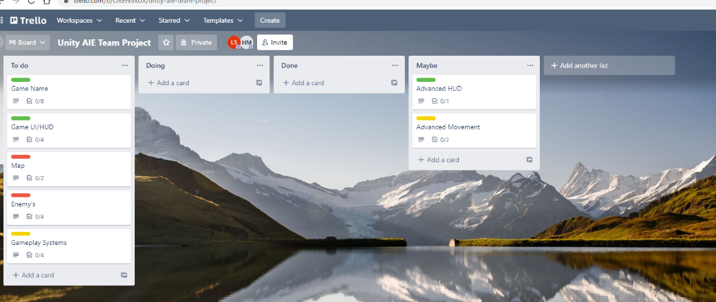

**GitHub Desktop –** started using GitHub but changed to bit bucket due to issues with program not accepting files over 100mb’s. Also had trouble with meta files.

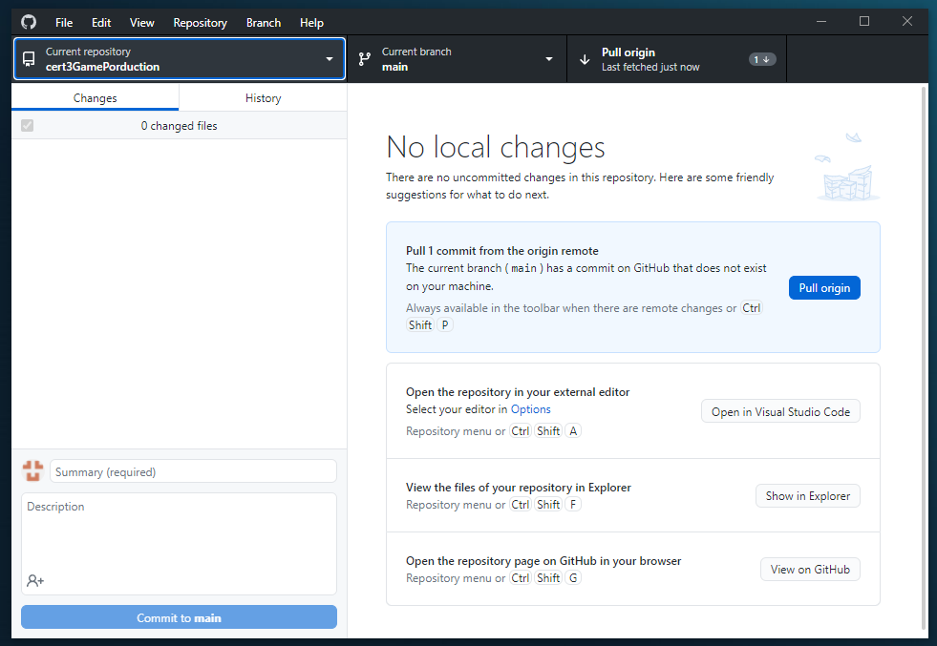

**BitBucket –** used bitbucket for version control instead of GitHub to get around the file size restrictions and found it a bit more user friendly.

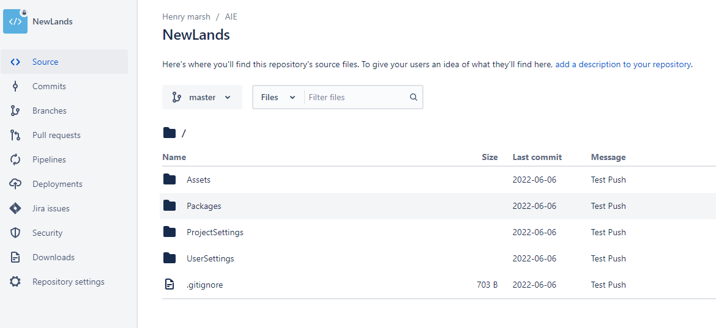

# Operating System Settings

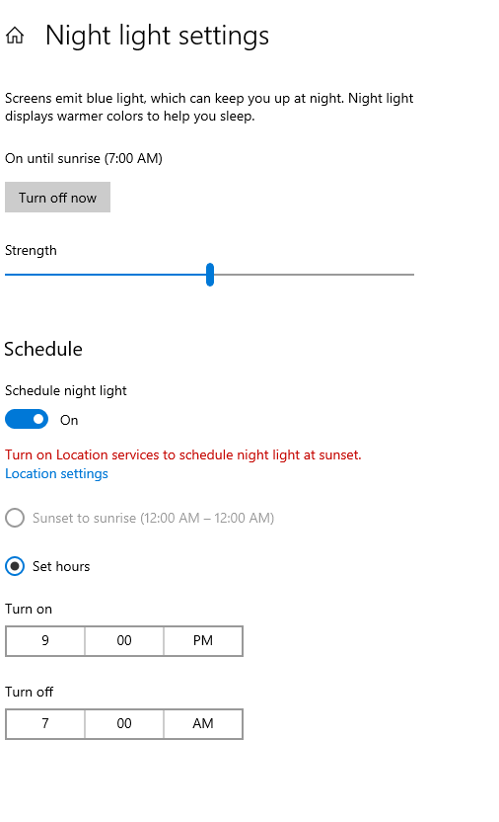

Didn’t adjust a whole lot with my display settings, set up the windows night light by following the tutorial. This was a nice setting to adjust as it takes away the sting of blue light on the eyes. After a while this can be straining on the eyes. Next option if this still persisted would be some computer glasses.

# Furniture Adjustments

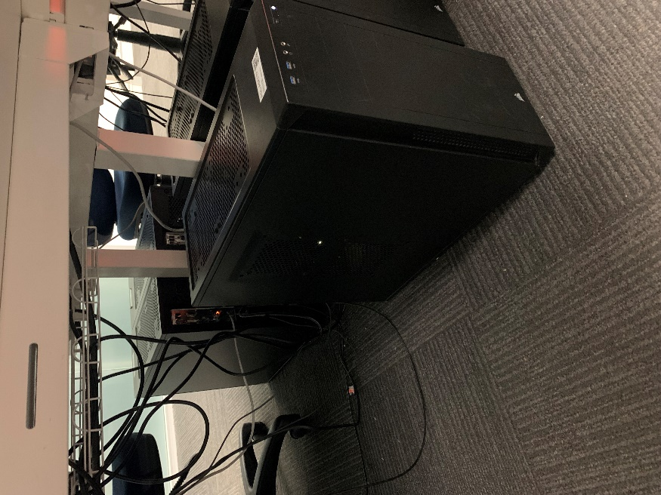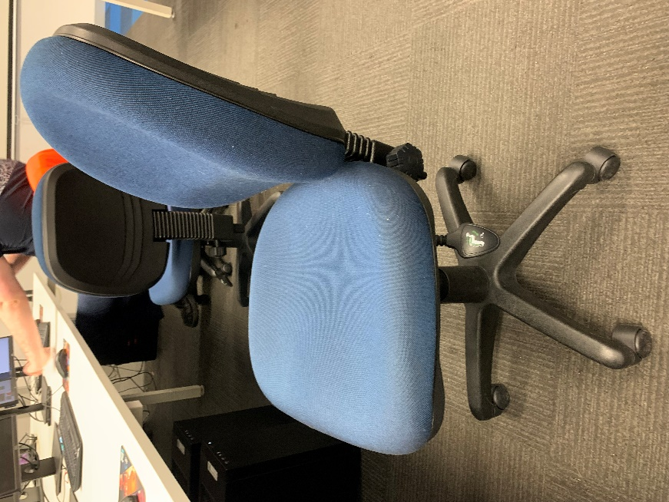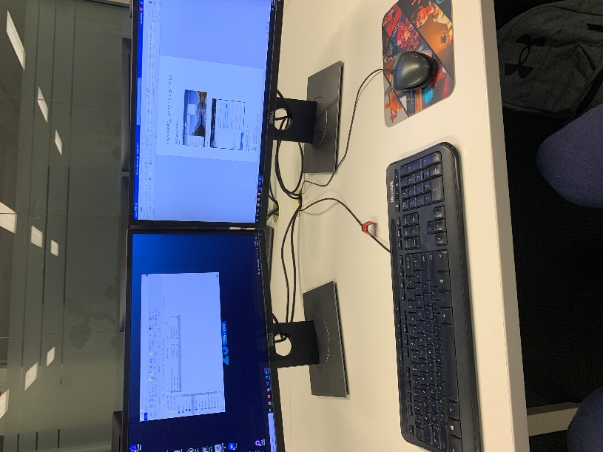

Used AIE equipment for most of the project which was good as the equipment here is set up well. Kept the tower under the desk and out of the way to avoid any damage and sometimes had a USB plugged in which can potentially get damaged if you become unaware it is sticking out. Set screens to the highest possible settings as I am tall. The chair was the most difficult thing to mess around with as I quickly become uncomfortable due to my size. Must be conscious of my posture as I tend to hunch a lot.